**Robo Phantoms**

**#23954**

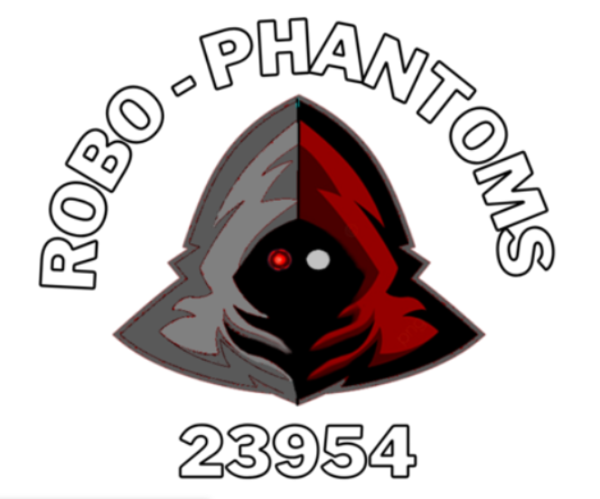

**Team Members:**

**Dhruv Shah**

**Harsh Desai**

**Kavin Sankaran**

**Kayan Patel**

**Coach:**

**Srinath Madasu**

Team Mission Statement:

We are a rookie FTC team all in our first year. Our team includes 5 hardworking kids and 1 strong coach. We want to spread awareness for the FIRST organization to inspire other people our age and younger to get involved in the robotics and technology field at an early age. We were very excited when we got the opportunity to participate in FTC and want other people to also have the same experience and have fun while learning about robotics. We do this by conducting fundraisers and always telling our friends about FIRST. We are very dedicated and meet every week to work on our robot and do the best work we can to conduct “Gracious Professionalism”

Team Roles

Dhruv Shah - Driver 1/CAD Designer

Kavin Sankaran - Head Programmer

Harsh Desai - Maintainance

Kayan Patel - Assistant Programmer

Srilakshminath Madasu - Driver 2/Designer

GAME ANALYSIS

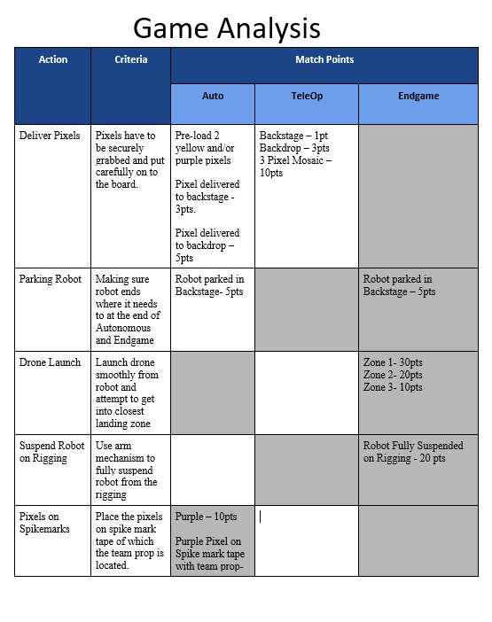

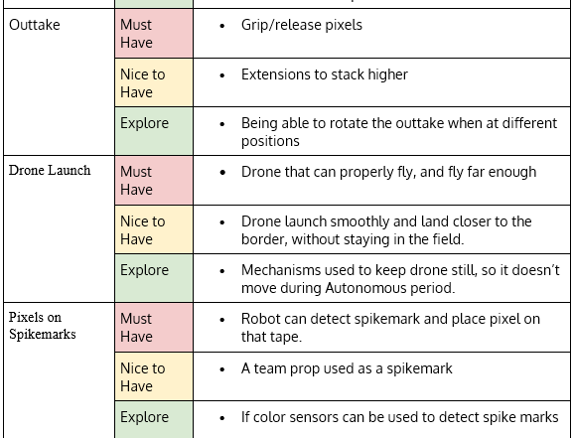

**DRIVETRAINS**

Drivetrains are used to facilitate the movement of the robot.

**Drivetrains**

Tank Drivetrain

One of the types of drivetrains is called Tank Drivetrain.

* This drivetrain primarily uses traction wheels (wheel designed for maximum grip) and cannot move sideways.
* Tank drivetrains prioritize **traction** over **maneuverability**.
* To turn, these wheels have to either run one side faster than the other, or have wheels in the opposite direction.

Holonomic Drivetrain

The other type of drivetrain is Holonomic Drivetrain.

* Holonomic drivetrain can move sideways by using mecanum or omni wheels.
* These wheels have specific rollers that allow them to move sideways (strafe). Holonomic drivetrain priortitzes **movement** over **traction**.
* This takes out the time it would take to turn in the tank drivetrain.
* However, holonomic can struggle with defense and can suffer with a heavy robot. Holonomic is very common among world-class robots.

**Omni Wheels**

These wheels share many advantages to mecanum wheels. 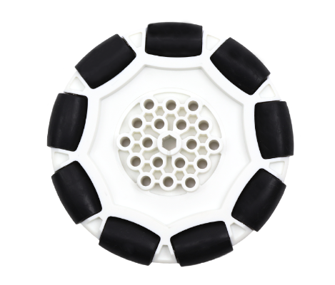

* Omni wheels have rubber rollers around the circumference of the wheel. This allows the wheel to roll perpendicular to the direction the wheel is driven.
* Each roller rides on a polished steel axle in order to minimize friction.
* The wheel can be driven with full force, but will also slide laterally with great ease.
* These wheels are also thinner and lighter than mecanum wheels.
* Omni wheels have a big disadvantage, traction. Because Omni wheels are nothing more than wheels on wheels, they tend to be very easily pushed around by other robots.

**Mecanum Wheels**

* Mecanum wheels rollers around the whole circumference of a steel plate rim, set at a 45 degree angle. 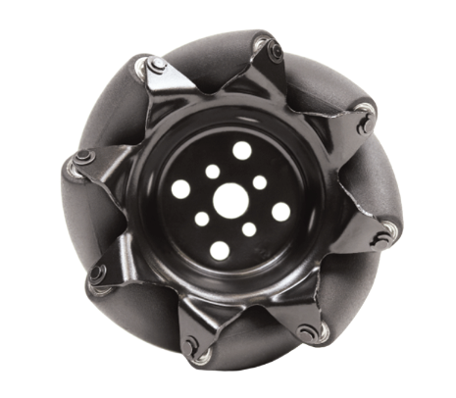
* Each side requires one left wheel and one right wheel to operate. When set up correctly, this allows **omni-directional movement** (movement in all directions).
* You have to configure them in specific orientations and each wheel requires its own motor to achieve all ranges of motion.
* The robot moves in a specific direction depending on which wheels are running.
* Mecanum wheels also require even weight distribution and the heavier the robot the less efficient the strafing is.

**Traction Wheel**

* Traction wheels are designed for **maximum grip.** 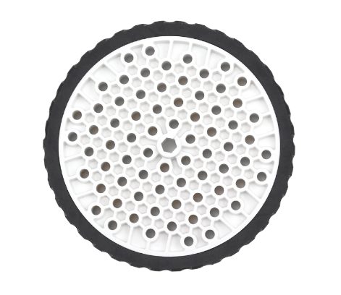
* These are the regular forward and backward wheels.
* It has an outer rubber ring and a wide track to ensure a larger contact patch with the ground.
* These wheels are very simple to work with and program.
* These wheels are found in Tank Drivetrains.

Intake/Outtake

**Types**

**of Intakes**

**Horizontal Intake**

The Horizontal Intake works by rotating on a horizontal

plane. This type of intake is best used for smaller game items. It can also control

more than one piece at a time. This intake was used successfully in games that

needed the robot to pick up small cubes and balls.

Vertical Intake

The Vertical Intake works by using wheels or other

components to intake the object. Best used with intaking larger objects. It is

also more controllable because it can only pick up items at a time.

**Roller**

**and Wheel Intakes**

Roller and Wheel Intakes use different wheels that make the

item go into a collection bin of some sorts. These are usually wider and can sometimes

intake more than one item at a time. Wheeled intakes usually have a slower RPM.

They also need more torque.

**Compliant Wheels**

Compliant wheels are pieces of wheel shaped rubber, usually

used for the Intake mechanism of a robot. When using compliant wheels, you must

make sure that you get the correct durometer (Hardness of the rubber), or else

you may not get the correct traction on the object you want to intake. A higher

durometer means more durability, but less traction (Not ideal for picking up

small objects). A lower durometer means more traction but less durability. More

traction is ideal for picking up the pixels. Good at controlling items with

flat surfaces. Can be spring loaded or locked into robot.

**Foam Wheel Intake**

Foam Wheel Intakes work the same as Compliant Wheels but

have worse traction and are less controllable.

**Rubber Band Intakes**

Rubber Intakes are made by 2 wheels on either side and

rubber bands stretched in between them. This creates a sort of roller that can

intake balls. The problem with Rubber Band Intakes is that they do not do very

well with intaking anything other than balls. They are also slower than a

Surgical Tubing Intake.

**Advantages/Disadvantages**

Some advantages to using Roller and Wheel Intakes are that

they are very controllable. Great at picking up and placing large items. Some

disadvantages are that they can only pick up one game piece at a time. The

items can also get jammed and can usually only pick up one shape.

**Tubing**

**Intakes**

Tubing Intakes work by using a tube that rotates at a high

RPM. Good at picking up smaller objects such as balls.

**Surgical Tubing Intake**

Surgical Tubing Intakes can be spring loaded into the robot.

Mostly used when the robot needed to transport smaller objects to a higher or

elevated surface. Always fixed at a certain height or angle. Test the stiffness

of the tubing because it may change the effectiveness of the intaking

mechanism.

**Advantages/Disadvantages**

Some advantages are that they are more efficient than

wheeled intakes. They are also able to carry more than one object at a time.

Some disadvantages are that they need a higher RPM and are less controllable.

Hard to pick up large objects.